EXPERIMENT 8

SAILOR BOAT DATABASE (DDL, DML, DQL, Subquery, Joins, Set operations)

Aim:

* Create sailors, boats, and reserves.(foreign key)
* Insert 5 values each table.
* Display all records.
* Find the names and ages of all sailors.
* Find all sailors with ratings above 8.
* Find sailors name with rating above 7 & age above 25.
* Display all the names & colours of the boats.
* Find all the boats with Red colours.
* Find the names of sailors' who have reserved boat number 103.
* Find the sids of sailors who have reserved blue boat
* Find the names of sailors' who have reserved Red boat.
* Find the colours of boats reserved by some name (provide any name in table).
* Find the names of the sailors who have reserved at least one boat.
* Find the names of the sailors who have reserved two different boats.
* Find the names of sailors who have reserved a Red or a Green boat.(union)
* Find the names of sailors who have reserved both a Red and a Green boat.
* Find the names of sailors who have reserved boat 103.(nested query)
* Find the names of sailors who have reserved red boat.(nq)
* Find the names of sailors who have not reserved red boat.(nq)
* Find the names of sailors who have reserved boat number 103.(exists)
* Find sailors whose rating is better than some sailors called name.
* Find sailors whose rating is better than every sailor' called name.
* Find the sailors with highest rating.
* Find the average age of all sailors.
* Find the average age of sailors with a rating of 10.
* Count the number of sailors.
* Count the number of different sailor ratings.
* Find the name and age of the oldest sailor.
* Find the names of the sailors who are older than the oldest sailor with a rating of 10.
* Find the age of youngest sailor for each rating level.
* Find the age of the youngest sailor who is eligible to vote (i.e., is at least 18 years old) for each rating level with at least two such sailors.
* For each red boat, find the number of reservations for this boat.
* Find all sailors name according to names.
* Find all sailors details according to rating.
* Find all sailors details according to rating (highest first) if ratings are same then according to age (youngest first).

MySQL:

**create table sailors(sid integer, sname varchar(30), rating integer, age real, primary key(sid));**

**create table sailors2 (sid integer, sname varchar (30), rating integer, age real, primary key (sid));**

**create table sailors1 (sid integer, sname varchar (30), rating integer, age real, primary key (sid));**

**create table boats (bid integer, bname varchar (30), color varchar (20), primary key (bid));**

**create table reserve (sid integer, bid integer, day date);**

**insert into sailors(sid, sname, rating, age) values(22, "Dustin", 7, 45.0), (29, "Brutus", 1, 33.0), (31, "Lubber", 8, 55.5), (32, "Andy", 8, 25.5), (58, "Rusty", 10, 35.0), (64, "Horatio", 9, 35.0), (85, "Art", 3, 25.5), (95, "Bob", 3, 63.5);**

**insert into sailors1 values (22, "Dustin", 7, 45.0), (31, "Lubber", 8, 55.5), (58, "Rusty", 10, 35.0);**

**select * from sailors1;**

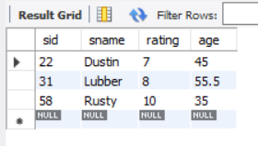

**insert into sailors2 values (28, "Yuppy", 9, 35.0), (31, "Lubber", 8, 55.5), (44, "Guppy", 5, 35.0), (58, "Rusty", 10, 35.0);**

**select * from sailors2;**

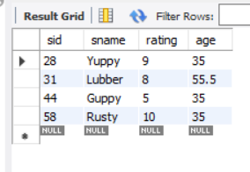

**insert into boats values (101, "Interlake", "blue"), (102, "Interlake", "red"), (103, "Clipper", "green"), (104, "Marine", "red");**

**select * from boats;**

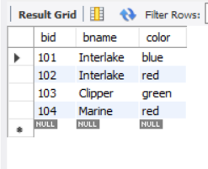

**insert into reserve values(22, 101, '1998-10-10'), (22, 102, '1998-10-10'), (22, 103, '1998-08-10'), (22, 104, '1998-07-10'), (31, 102, '1998-10-11'), (31, 103, '1998-06-11'), (31, 104, '1998-12-11'), (64, 101, '1998-05-09'), (64, 102, '1998-08-09');**

**select * from reserve;**

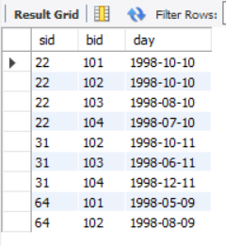

**Activity 1:**

**select * from sailors2 cross join sailors1;**

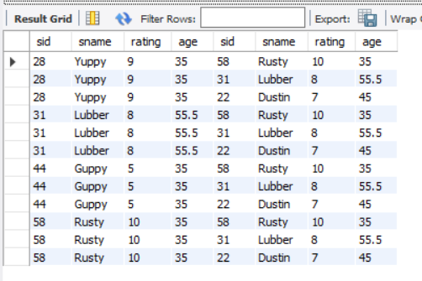

**select * from sailors1 inner join sailors2 on sailors1.sid = sailors2.sid;**

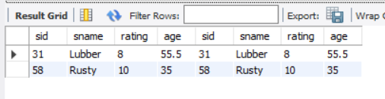

**select * from sailors1 left join sailors2 on sailors1.sid = sailors2.sid;**

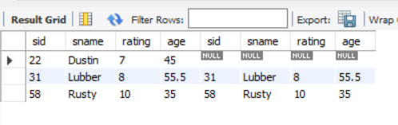

**select * from sailors1 right join sailors2 on sailors1.sid = sailors2.sid;**

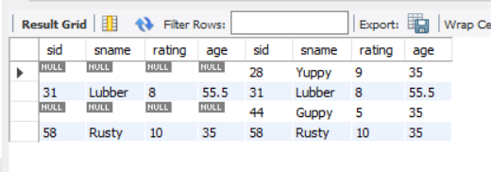

**select * from sailors1 union select * from sailors2;**

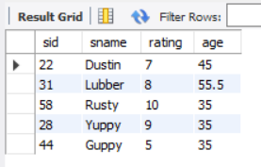

**select * from sailors1 union all select * from sailors2;**

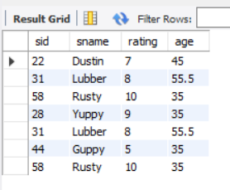

**select distinct sid from sailors1 inner join sailors2 using(sid);**

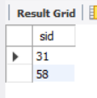

**select sid from sailors1 left join sailors2 using(sid) where sailors2.sid is null;**

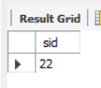

**select s.sname from sailors1 s left join reserve on s.sid = reserve.sid where reserve.bid = 101 ;**

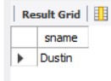

**select s.sid from sailors1 s where s.sid in (select r.sid from reserve r where r.bid in (select b.bid from boats b where b.color = "green"));**

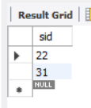

**select b.color from boats b where b.bid in (select r.bid from reserve r where r.sid in (select s.sid from sailors1 s where s.sname = "Dustin"));**

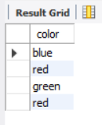

**select distinct s.sname from sailors1 s inner join reserve r on s.sid = r.sid;**

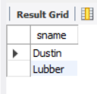

select s.sname from sailors2 s left join reserve r on s.sid = r.sid where r.bid = 103;

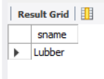

select s.sname from sailors1 s where s.sid in (select r.sid from reserve r where r.bid in (select b.bid from boats b where b.color = "red")) union

select s.sname from sailors1 s where s.sid in (select r.sid from reserve r where r.bid in (select b.bid from boats b where b.color = "green"));

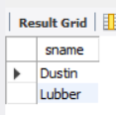

select s.sname from sailors2 s where s.rating = (select max(s.rating) from sailors2 s);

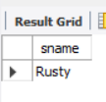

select s.sid from sailors1 s where s.sid in (select r.sid from reserve r where r.bid in (select b.bid from boats b where b.color = "red"));

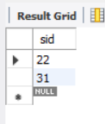

select avg(age) from sailors2;

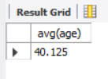

select avg(age) from sailors2 where rating = 10;

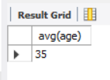

**select count(sid) from sailors2;**

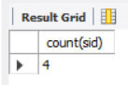

select avg(age) from sailors2 where rating = 10;

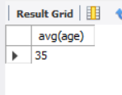

select count(sid) from sailors2;

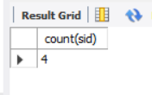

select distinct count(rating) from sailors2;

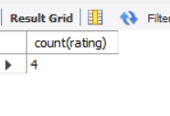

select sname, age from sailors1 where age = (select max(age) from sailors1);

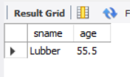

select sname from sailors where rating = 10 and age > (select max(age) from sailors1);

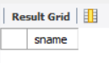

select count(*) from reserve r where r.bid IN (select b.bid from boats b where b.color = 'red');

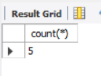

select s.rating, min(s.age) as minage from sailors s group by s.rating;

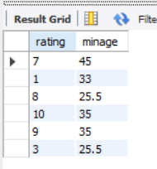

select s.sname, s.rating, min(s.age) as minage from sailors s where s.age > 17 group by s.rating having count(*) > 1;

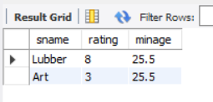

select s.rating, s.sname from sailors s where s.rating > any(select s1.rating from sailors s1 where s1.sname = 'Dustin');

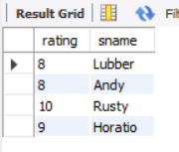

select s.rating, s.sname from sailors s where s.rating > all(select s1.rating from sailors s1 where s1.sname = 'Dustin');

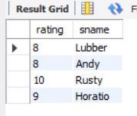

select * from sailors order by sname asc;

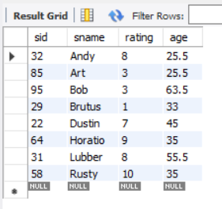

select * from sailors order by rating asc;

